

**Work Plan**

Project Team

**Fall Semester**

Cherlyn Chan

Michael Lertvilai

Joži McKiernan

Nithya Menon

Heather Seaman

Project Advisor(s): Prof. Brian Bryce

Project Liaison(s): David Zielski

October 2015/2016

ABSTRACT TESTING

The RainCatcher Clinic Team at Harvey Mudd College will design, build, and test a device for monitoring and reporting on tasdfasdf asdfkjkhe performance of rain catchment tanks in Kenya, Uganda, and the Navajo Nation. This work plan presents the initial design and approach for the project. It describes multiple potential alternative solutions, which will be useful based on the prototyping and testing process. The team will focus on building a working prototype in the fall such that the team can make additional improvements and have a design ready to be tested at field locations come spring. This project is heavily constrained by the self-sufficient, remote location, and low-budget nature of the project.

TABLE OF CONTENTS

TOC \o 2-3 \t "Abstract Heading, 4,Appendix Heading, 5,Heading, 6"

ABSTRACT TESTING PAGEREF _Toc \h 3

1. **introduction PAGEREF _Toc1 \h 1**
   1. Raincatcher PAGEREF _Toc2 \h 1
   2. Project Statement PAGEREF _Toc3 \h 2
      1. *Objectives PAGEREF _Toc4 \h 2*
      2. *Constraints PAGEREF _Toc5 \h 2*
      3. *Functions PAGEREF _Toc6 \h 3*
   3. Deliverables PAGEREF _Toc7 \h 4
2. **Background PAGEREF _Toc8 \h 6**
   1. Power PAGEREF _Toc9 \h 6
   2. Volume Sensing PAGEREF _Toc10 \h 10
   3. System Control PAGEREF _Toc11 \h 13
   4. Data Transmission PAGEREF _Toc12 \h 14
3. **technical approach PAGEREF _Toc13 \h 17**
   1. Design alternatives PAGEREF _Toc14 \h 17
      1. *Power PAGEREF _Toc15 \h 17*
      2. *Volume Sensing PAGEREF _Toc16 \h 21*
      3. *System Control PAGEREF _Toc17 \h 23*
      4. *Data Transmission PAGEREF _Toc18 \h 25*
      5. *Housing PAGEREF _Toc19 \h 28*
   2. Preliminary design PAGEREF _Toc20 \h 29
      1. *Power PAGEREF _Toc21 \h 29*
      2. *Volume Sensing PAGEREF _Toc22 \h 30*
      3. *System Control PAGEREF _Toc23 \h 30*
      4. *Data Transmission PAGEREF _Toc24 \h 31*
      5. *Housing PAGEREF _Toc25 \h 32*
   3. testing PAGEREF _Toc26 \h 32
4. **Project Management PAGEREF _Toc27 \h 35**
   1. Work Breakdown Structure PAGEREF _Toc28 \h 35
   2. Schedule PAGEREF _Toc29 \h 36
   3. Division of labor PAGEREF _Toc30 \h 37
5. **References PAGEREF _Toc31 \h 38**
6. **team member profiles PAGEREF _Toc32 \h 42**

# introduction

RainCatcher is the client for the 2015-2016 Global Clinic Project. The Clinic team will develop a system for capturing and reporting performance data on the status of RainCatcher’s rainwater catchment tanks in Kenya, Uganda, and the Navajo Nation. This section describes RainCatcher as an organization, presents the project statement, and defines the deliverables for the project.

## Raincatcher

RainCatcher is a nonprofit organization that installs rain catchment and filtration systems to provide clean water to isolated or underdeveloped communities. Most of these communities receive ample rainfall but have no way of storing rain. They rely upon distant, and often contaminated, sources of groundwater for drinking and washing. RainCatcher chooses to provide clean water adjacent to schools so that children can receive an education and bring water home instead of walking for hours each day to fetch water. The construction and installation of these tanks are funded by donors from around the world.

Once the tanks are installed, RainCatcher is committed to maintaining its systems for ten years. While most of the system is quite durable, the taps and gutters on the tanks are prone to failure. There is currently no good way to check whether or not the catchment systems are functioning normally, and communities are generally reluctant to report any malfunctions. The sites do not have reliable Internet service, which makes communication difficult. As a result, local agents make quarterly visits to each tank site, and U.S. agents make an annual trip. These visits are a significant financial burden on RainCatcher. RainCatcher seeks a way to remotely monitor its systems to make the maintenance process more efficient. RainCatcher also hopes to use the monitoring data to engage their donors by showing them data from the tank’s use.

## Project Statement

The 2015-16 RainCatcher Clinic Team will design, develop, build, and test a system to monitor and communicate the water volume for each of RainCatcher’s systems.

### Objectives

Objectives for the monitoring system include:

* Minimize costs
* Minimize the possibility of theft
* Report data
* Be simple to install and maintain
* Reliably log data daily and send data as close to daily as possible

### Constraints

The design must meet the following constraints:

* Operate within the temperature range of -20°C to 50°C
* Operate under high winds and varying environmental elements
* Be self-sustaining, in regards to power and operation
* Cost less than $30
* Not interfere with the structural integrity of the tank without increasing the risk of tank failure
* Maintain the health standard of the water without introducing further impurities

### Functions

The design should perform the following primary functions:

* Measure water volume
* Process data
* Store data
* Send data
* Power the system
* Protect monitoring system from theft and weather conditions

Given the team’s success in implementing the primary functions, the team will direct attention to these following secondary functions:

* Visualize data via a web platform
* Measure water clarity
* Measure water temperature
* Measure tank cleanliness
* Detect rainfall
* Measure the exit flow rate of the water
* Report tank status when in need of maintenance

## Deliverables

By the end of the fall semester, the team will deliver:

* Multiple design alternatives for the monitoring system
* An evaluation of these designs
* A schematic and a professional model of the preferred alternative
* A functional prototype
* A test plan for evaluating the prototype
* Project documentation and presentations including:
  + Work Plan
  + Midyear Report
  + Design Review with RainCatcher
  + Three internal Clinic presentations

By the end of the spring semester, the team will deliver:

* An improved monitoring system, possibly including some secondary functions
* Formalized test results
* Project documentation and presentations including:
  + Final Report
  + Detailed engineering drawings of the system
  + Complete documentation of the fabrication process for the system
  + Spring semester presentation at Harvey Mudd College
  + Projects Day presentation
  + Final Presentation to the Malibu Rotary Club or RainCatcher Board of Advisors

# Background

Based on initial research into possible solutions, the team broke the overall system into several subsystems. These subsystems can be visualized in the block diagram below, in Figure 1.

Water Tank

Sensing

Power

System Control

Data Transmission

Figure 1: Block diagram of the subsystems of this project.

There are many ways to solve the problem at hand and build each subsystem. This section will detail some of the most common methods which can inform the design of the primary subsystems of this project: power, volume sensing, system control, and data transmission.

## Power

There are two main approaches to provide electrical power to a system without access to an electrical grid. The first is to use stored energy, and the second is to generate electricity. There are limitations pertaining to the reliability and efficiency of large-scale energy storage, but due to the low power requirements of this project, this section will focus on small-scale batteries. Batteries store energy in the form of chemical energy that can then be converted to electricity. A basic schematic of a battery in a circuit is shown below in Figure 2.

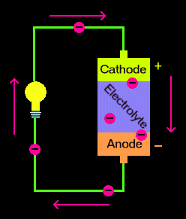

Figure 2: Schematic of a basic battery [1].

As shown in Figure 2, a battery has three main components, the cathode, anode, and electrolyte. The anode and cathode are metals, where the metals are chosen based on their ability to oxidize (receive electrons) and reduce (give away electrons), respectively. The electrolyte is the conductive medium for the electrons to transfer through. Due to the anode’s affinity to oxidize, electrons flow across the electrolyte from the cathode to the anode [2]. Thus a charged battery has a surplus of electrons in the anode and a lower number of electrons in the cathode, which creates a charge differential. As soon as the circuit is completed, the electrons begin to flow from the anode to the cathode, which creates electricity and depletes the potential in the battery. In a non-chargeable battery, once this potential is depleted and the anode and cathode become neutralized, the battery is dead [3].

An alternative to relying on a disposable battery is to use a rechargeable battery. A common system to recharge a battery involves using solar energy. To recharge a battery, an external power source runs current through the battery in the opposite direction, which causes an electrochemical reaction to reset the original chemical compounds. The forward reaction then becomes available for electrons to flow from the anode to cathode again [3]. Rechargeable batteries can provide more power over their lifetime than disposable ones, but they have a higher self-discharge rate [3]. The following figure demonstrates a simple way to construct a solar panel charging circuit.

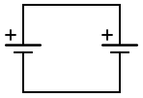

Solar Panel

Rechargeable Battery

Figure 3: Basic schematic for recharging batteries via solar panel outputs

This circuit directly sends the electricity generated from the solar panel to the batteries, but it doesn’t protect the system from being damaged. Batteries can be damaged by being charged too quickly, for too long, or with too much power. Solar panels can be damaged when current switches direction after the batteries are fully charged [4]. Thus the charging circuit needs to be improved.

Figure 4, shown below, shows how a diode can be added to the circuit to prevent current from flowing in the wrong direction.

Solar Panel

Rechargeable Battery

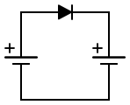

Diode

Figure 4: Solar powered battery charging with a diode to control the direction of current flow

The next level of protection to consider would be to control the power being used to charge the battery. Figure 5 shows the LM317 voltage regulator being used to control the current flowing out of the solar panels into the battery.

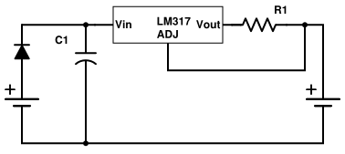

Solar Panel

Rechargeable Battery

IOUT =

Figure 5: A LM317 voltage regulator can be used to regulate the current into the charging batteries.

A microcontroller can be used to monitor the voltage across the battery and control the level of charging based on the charge of the battery. If rapid charging is not needed, a trickle charge - that is, the slow-charging current - can be run through the battery for long periods of time without affecting the battery’s lifetime. The specifics of the charging control method will depend on the batteries, and the power available.

The two most commonly used and accepted form of rechargeable betters are nickle

## Volume Sensing

Sensing the volume of fluid in a tank is a solved problem for many companies in the petrol industry and other companies dealing with tanks. Most industrial solutions integrate multiple sensors and wireless data reporting with proprietary software for remote management. The sensing solutions, range from mostly mechanical to mostly electrical in nature.

One common mechanical solution is to use a float attached to a rod that runs the length of the tank. The float contains a magnet; the rod contains a number of switches along its length. As shown in Figure 6, when the liquid level rises, so does the float, although it is constrained to rise along the rod. The magnet activates a switch when the float passes near enough to that point on the rod. The height of the fluid in the tank can then be approximated by determining which switch along the height of the tank was most recently activated, and the volume of fluid can be calculated if the dimensions of the tank are known [5][6],.

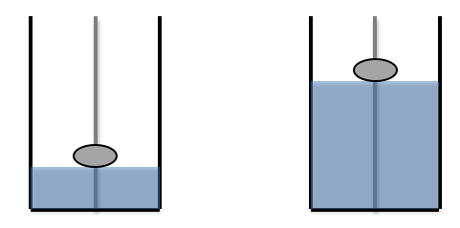

Figure 6: A mechanical float at low volume (left) and higher volume (right).

Other more “invasive” methods used industrially include resistance and capacitance strips. These devices consist of strips, consisting of either rods, tape, or other type of leads that project into the tank. As the fluid in the tank changes, it alters the resistance or capacitance of the sensing circuit because the water closes the circuit at different heights.  This change can by measuring the impedance, and processed to deduce the volume of fluid in the tank.

Another common method of determining the volume of fluid in a tank is to use an absolute or differential pressure sensor. Absolute pressure sensors measure the pressure at the base of a water column (i.e. at the bottom of a tank) relative to a vacuum. The volume of water in the tank can be determined based on the height of the liquid and the dimensions of the tank. In contrast, differential pressure sensors measure the difference in pressure at the bottom of the tank and the ambient pressure. The difference in pressure correlates with the amount of liquid in the tank, as seen in Figure 7.

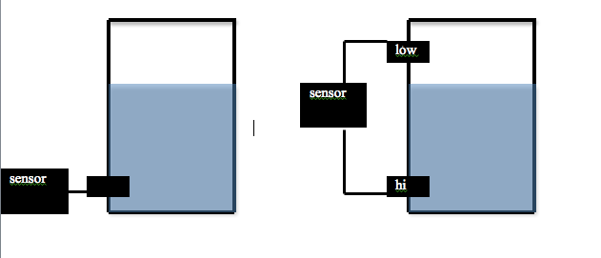

Figure 7: Schematics of a (left) absolute pressure sensor equipped to monitor a water tank and (right) a differential pressure sensor equipped to monitor a water tank, with high and low pressure valves marked.

In addition to the “contact” methods of measuring fluid levels above, ultrasonic sensors, radar, or lasers can be used to measure volume in a tank without directly touching the liquid. An ultrasonic sensor can be mounted on the top of the tank with its sensing side facing down towards the water.  The sensing begins with the sensor emitting an ultrasonic pulse aimed at the surface of liquid in the tank. When the pulse reaches the surface of the liquid, it bounces back towards the sensor, as seen in Figure 8. The sensor measures the time between when the pulse is emitted and when it is received. Because the pulse travels at known speed through air, the distance between the top of the tank and the height of the fluid in the tank can be calculated, and from there the volume of fluid in the tank can be determined. The amount of fluid in the tank can be measured in the same way using a laser or radar pulse instead of an ultrasonic pulse simply by using the appropriate emitter and detector for each type of wave.

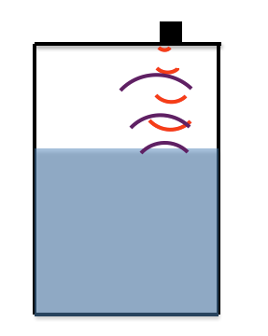

Figure 8: Schematic representation of non-contact methods of level detection. The sensor (black box) emits a pulse (red curves) which eventually bounces off the surface of the water (purple curves) and is detected by the sensor.

All of these methods of volume monitoring require additional processing and/or control. Thus, we will need to consider sensor compatibility with various controllers in addition to factors such as size, accuracy, and ease of installation when selecting a method for determining the level of water in the tank.

## System Control

The initial research reveals that a solution involving electronic systems is more viable than a purely mechanical one. An electronic solution needs a central unit to process information that streams through the system. This task can be accomplished by a microcontroller, a small integrated circuit containing a processing core, memory, and programmable input/output peripherals. A microcontroller operates by using a certain arrangement of logic and digital building blocks such as registers, finite state machines and arithmetic logic units. A particular microcontroller has its unique architecture that entails specific trade-offs between performance, cost and complexity. For example, a microcontroller with a simple architecture might be very cheap but have a very low performance that cannot perform certain tasks [7]. For this project, the desired microcontroller needs to perform the following functions: accept inputs from water level sensors, format and send the data to the transmission unit. These functions, along with other constraints, play an important role in choosing an appropriate microcontroller for this project.

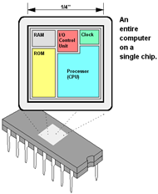

Figure 9: A general architecture of a microcontroller [8].

## Data Transmission

The methods used to transmit data from place to place are well-established and diverse, however, for the purposes of this project the team must choose a data transmission method which fits within the constraints. Primarily, we must choose a method which will work in remote areas which may potentially have low connectivity and transmission speeds. The team has researched a transmission standard called Global System for Mobile Communication (GSM), more commonly known as 2G or 3G. In most parts of the world GSM transmits over 900/1800 MHz frequency bands, however within US and Canadian borders GSM networks use 850/1900 MHz bands, thus the team must ensure compatibility of the delivered prototype across global regions. GSM uses General Packet Radio Service (GPRS), a best-effort protocol which uses Time Division Multiple Access with a throughput up to 15 kilobytes/sec over a 2G network [10][11]. GSM devices are identified by the network and have their permissions verified via a Subscriber Identity Module, often called a SIM card. Given the availability of GSM network in the relevant locations, the team can equip a microcontroller to transmit data to an Internet-accessible server, as shown in Figure 8.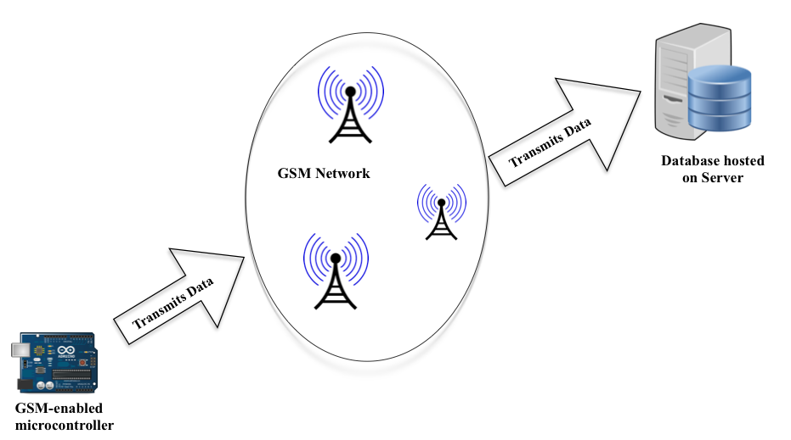

Figure 8: Overview of GSM Network [12].

In some cases GSM networks will not be available, yet data still can travel from place to place using technologies which do not rely upon cellular networks. These include satellite and long-range packet radio networks. Satellite transmission would require additional large hardware components attached to the team’s system, as well as requiring a higher level of power consumption to generate a strong radio signal which could be received in space. If long-range radio waves are used to transmit data, the team’s solution would require a network-connected radio transceiver to upload sensor data to the Internet. Data packets can be transmitted to a common base using the AX.25 protocol which is traditionally used among amateur radio operators [13]. All three of these technologies can be utilized with a micro-processing unit, but the ease of integration, power-consumption, and financial costs associated with each must be considered before choosing a primary implementation strategy.

# technical approach

Since the primary goal of this project is to produce a well-tested, highly functional prototype, the team will begin prototyping and testing as early as possible. In order to make sure there is enough time for designs to fail and be revised, early prototyping is a fundamental part of the design process. This section will discuss the design alternatives considered by the team and will conclude with a description of the most viable design that will be pursued for the first prototype. Early prototypes will depend more heavily on commercial products for ease of timely design, but many of these components may eventually be built in-house to reduce costs.

The team has started by comparing multiple methods of meeting each function. Section 3.1 enumerates the alternatives presently under consideration and provides an initial comparison of the alternatives.  Section 3.2 describes how the team plans to complete a detailed design of the preferred alternative, and Section 3.3 addresses testing.

## Design alternatives

In this section the team presents proposed design alternatives for each distinct component of the system. The costs and benefits of each design alternative are discussed as well as its effect upon related components.

### Power

As discussed in the Section 2.1, there are a few different ways to power a system off-grid. This section will outline three primary alternatives- sustainable battery charging, disposable batteries, and rechargeable batteries. The first method to provide electricity to the system is to use a renewable source to charge rechargeable batteries, and power the system from the batteries. Variations on this design are due to different renewable energy sources, i.e. solar, a wind turbine, or a water turbine in the tap of the tank to harness the flowing water energy. A solar panel or wind turbine would need to be installed at the top of the tank, whereas the water turbine would need to be fixed into the tap.

The second and third if the system consumes low enough power to run for a year on two to four AA (or similar) batteries, the client would be satisfied. Given that on-site visits to each tank would never be completely eliminated, even with good remote performance data, a minimal amount of annual maintenance at each site could be considered. Batteries are valuable at the field locations, so hiding and/or securing the batteries will be an important aspect of either design.

Using renewable energy to charge the system would raise the upfront cost of the system, but it would be more sustainable and could withstand higher power demands. Using new batteries each year would decrease the initial cost of the system, but it would contribute to the ongoing cost of the system and to other environmental concerns.

Since cost is the most limiting constraint and low-maintenance is priority, the most viable method for renewable power is solar. Solar panels, for the scale of power required, can be less than $5 from Sundance Solar. From research on Amazon, eBay, and turbine manufacturers, wind turbines or water turbines would far exceed the $30 budget alone and the requirement of wind at each tank is difficult to guarantee. Additionally, dependence on mechanical systems and moving parts increases the risk of system failure. Solar panels are less complicated to install and would more reliably generate power. The client seems to favor a minimally invasive solution, which, in addition to cost, is another deterrent from a water turbine. Such a design would need to adapt to multiple tap fitting sizes and would create high risk for leaks or tank failure.

Ultimately, research into design alternatives for powering the system come down to a combination of solar and batteries. Table 1 compiles some of the product alternatives to build a system powered by solar charged batteries or primary batteries. The product information is taken from the specifications as reported by the vendors Amazon, Sundance Solar, SunLabz, eBay, and DigiKey as accessed on September 21, 2015.

|  |  |  |  |
| --- | --- | --- | --- |
|  | **Product** | **Cost (USD)** | **Output** |
| **Solar Panel** | EachBuyer, mini Panel for DIY charger | 2.25 | 5V 160mA |
|  |  |  |
| Sundance Solar, 700-10850-21 | 5.39 | 4V 100mA |
| **Rechargeable Batteries** | AA NiMH AmazonBasics | 1.70 per unit | 2,000 mAh |
| SunLabz, AA NiMH | 2.00 per unit | 2,600 mAh |
| **Charger IC** | TSM101AIDT | 0.75 | -0.3 to Vcc-1.5 |
| L7805 Voltage Regulator | 0.95 | 5 V |
| **Disposable Batteries** | Amazon AA Duracell | .40 per unit | 1.5 V |
| Amazon AA AmazonBasics | .30 per unit | 1.5 V |

Table 1: Product comparison chart for power components.

Because the system only needs to be awake to collect data once a day, the batteries can be slow-charged gradually throughout the day. This means that a low power solar panel will be sufficient. The exact number of batteries that would be necessary to power the system will depend on the other subsystems of this project.

Table 2 summarizes the three most viable design alternatives for powering the system. The first is the only fully self-sufficient model, where two batteries are used and recharged via solar. The second is to use rechargeable batteries, and on each annual visit, the rechargeable batteries can be removed, different batteries can be installed, and the depleted batteries can be charged to be used at another site. The third model is to buy and replace the disposable batteries at each location. The pricing for these alternatives is based off of the product listed in Table 1.

|  |  |
| --- | --- |
| **Power Source** | **Approximate Price** |
| Solar Panel, 4 rechargeable batteries, IC | $13 (one time cost) |
| 4 rechargeable batteries | $8 (one time cost, annual maintenance) |
| 4 disposable batteries | $1.50 (annual cost, annual maintenance) |

Table 2: Cost comparison of power design alternatives.

### Volume Sensing

As discussed in the technical background Section 2.2, there are many options for sensing the level of water in the tank. Key considerations when evaluating possible sensor systems include cost, ease of installation/calibration, power consumption, processor compatibility, accuracy, precision, resolution, response/output format, and failure rate.

A float mechanism may be costly because of the internal magnets and the complicated installation process. The float requires little electronic calibration and processing or control but may require significant modifications to the tank during installation. Also, the float is largely mechanical, and even though it would consume a small amount of power, moving parts are the most prone to failure.

Commercial resistive water level sensors are very expensive, priced about $5 for a strip spanning a few inches and nearly $40 for a sensor about one foot long [13][14].  However, it is also possible that a non-commercial resistance sensor could be constructed in-house at a lower cost. As RainCatcher’s tanks are 1.5-3m tall, several commercial sensors would be needed to give useful water depth readings, resulting in a high expense. In addition, the strips would need to be installed along the length of the tank, increasing the invasiveness of installation. A significant barrier to this method is not knowing the impedance of the rainwater. Murky or contaminated water will have higher impedance than pure water, making it difficult to detect small changes in impedance due to the water level without using dangerous amounts of current.

An absolute pressure sensor could be mounted by drilling into the side of the tank or possibly dropping the sensor into the tank. The absolute pressure sensors which meet the required functions and constraints are about $10-$15 [15]. Calibration procedure is usually given by the manufacturer. In addition, research suggests that the sensors require fairly low current, about 1-2 mA.  In terms of compatibility, many available absolute pressure sensors output voltage, which should be compatible with most processors. One sensor provides 0.5% static accuracy, which should meet system requirements. The most likely point of failure for this method is the port on the sensor, to which we’d have to connect a tube, which would be vulnerable to failure. In addition, this method depends largely on ambient pressure and on the fluid having constant density.

A differential pressure sensor costs more than an absolute pressure sensor. This type of sensor also depends on the fluid having constant density, but it is independent of ambient pressure. One of the least expensive differential pressure options, MPX5050DP, has a maximum error of 6.25% over an operating temperature of -40°C to 125°C and functions at pressures up to 200 kPa [16]. This sensor requires 5V of power and produces a DC voltage output. The difficulty of calibration and installation depends on where in the tank the sensor is installed.

Of the many ultrasonic sensors available, cost suggests that the HC-SR04 is one of the most viable alternatives for this project. The HC-SR04 is available for under $3 and can be installed simply at the top of the tank. It has a sensing range of 2-450cm and a precision of up to 3mm [17]. A potential issue with an ultrasonic sensor is that the accuracy of the measurement depends on the geometry of the tanks. Depending on the radius of the signal, especially if the water level is low and the signal is traveling long distances before returning, the sonar wave may become too dissipated or interfere with the tank walls.

Investigation into other non-contact methods of measuring the water level (lasers, radar sensor) demonstrated that they would be prohibitively expensive. Radar level sensors ranged from about $500 to over $5000. Cheap lasers exist, but consume large amounts of power and might be difficult to align.

### System Control

There are a large variety of microcontrollers that are capable of all required functionalities described in Section 2.3. The system has to cost less than $30, so the microcontroller unit has to be relatively cheap. Additionally, this project has a relatively short time limit of only two academic semesters, so microcontrollers that have readily programmable platforms are preferred. These microcontrollers will shorten the time required to configure them to be functional.

A widely supported programmable platform is Arduino. This platform has several libraries that abstracts away most of low-level programming and also has a variety of development boards that significantly eases the process of programming. As a result, Arduino-compatible microcontrollers are examined. Table 3 compares price, performance and functionalities of four chips from three different families. All data were extracted from the datasheet of each chip provided by Digikey website as of 9/20/2015.

|  |  |  |  |  |
| --- | --- | --- | --- | --- |
|  | **ATMega328** | **ATMega2560** | **ATTiny84** | **SAM3X8E** |
| **Family** | megaAVR | megaAVR | tinyAVR | ARM Cortex-M3 |
| **Unit Price (USD)** | 2.47 | 12.94 | 1.25 | 9.39 |
| **ADC Accuracy (bits)** | 10 | 10 | 8 | 12 |
| **ADC Channel** | 8 | 16 | 8 | 12 |
| **Digital Pin** | 14 | 54 | 11 | 54 |
| **Speed (MHz)** | 16 | 16 | 20 | 84 |

Table 3: Arduino compatible chip comparisons.

The two low-end chips are ATMega328 and ATTiny84. ATMega328 is the current official chip used on Arduino USB Board (UNO R3) [18]. It is compatible with most existing Arduino libraries and shields, so ATMega328 can be readily programmed without prolonged chip configuration [19]. ATTiny84 has fewer pins and has a lower Analog to Digital Converter (ADC) resolution than ATMega328. It is also not officially supported by Arduino platform, but some modifications can be made to make it compatible [20]. Even though ATTiny84 is not as readily programmable and powerful as ATMega328, it costs less than half the price of ATMega328. These two chips have both surface-mount and through-hole counterparts, so they are very easy to use in a prototype without the need for breakout boards.

The two high-end chips are ATMega2560 and SAM3X8E. Both chips have a very high number of analog and digital pins. SAM3X8E also boasts a better ADC accuracy of 12 bits and a relatively fast clock cycle of 84MHz. ATMega2560 and SAM3X8E are compatible with Arduino programming platform, but they might not be supported by all libraries, especially those written specifically for Arduino UNO. Despite the relatively high costs, both chips can handle demanding tasks and also allow the project to be readily expandable because of available pins. However, these two chips do not have a through-hole version, so using them in a prototype will be challenging.

### Data Transmission

In this project, one of the primary concerns is the availability of a cellular network in undeveloped areas of Kenya, Uganda, and the Navajo Nation. In cases when a cell signal is available, it is straightforward to equip a microcontroller to transmit the collected data. The existing cellular network infrastructure is already designed to relay data to an Internet server [See Figure 8 in Section 2.4 above]. The data can then be formatted and presented to a user on a web page.

In cases when a cellular connection is not available, the team must implement an appropriate secondary data handling system. Other alternatives under consideration include satellite and radio transmission. Both of these alternatives are feasible, however, they require more hardware components, likely increasing overall financial costs and power consumption. The cost associated with a satellite-connected device is substantially more than that of a cellular device, but it does guarantee global coverage. Radio transmission can be done using packet network transmissions to a shared transceiver within the range of the transmitting device. Cursory research suggests that packet radio transmitters can transmit ranges of up to 60 kilometers, a distance which is sufficient for many tank locations. Based on the GPS coordinates of existing tank locations, as shown in Figure 9, it appears that many of the tanks are located in regional clusters, increasing the utility of a centrally located radio transmitter.

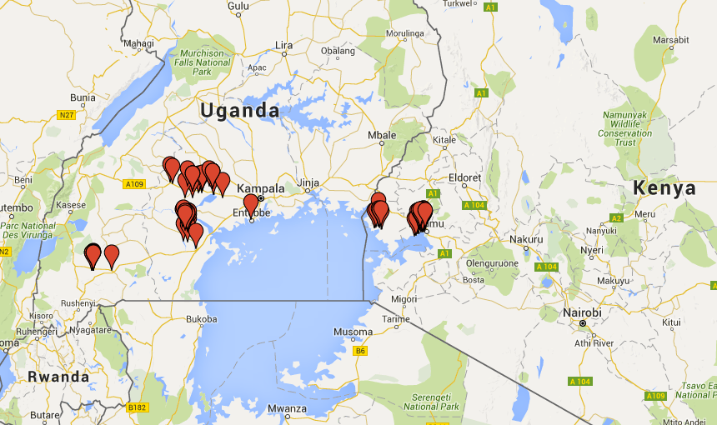

Figure 9: GPS locations of RainCatcher tanks in Kenya and Uganda.

An approach utilizing packet radio transmission instead of cellular networks, however, may require installation and maintenance of many additional network nodes, such as base transceiver stations. These stations would need to be placed in the range of multiple tanks and individually configured to upload data to the Internet. While radio is a potentially feasible secondary alternative, it introduces significant complexity and cost to the system. Both satellite and packet radio technologies may utilize more power than an implementation using a cellular network due to the fact that they do not rely upon existing network infrastructure and attempt to transmit over longer ranges.

Formatting data will vary depending on the transmission or storage method employed. The primary design alternative involves transmitting formatted, packetized data over an existing cellular network. If data is transmitted over a GSM cellular network it would be intuitive to send the data in the body of one or more network messages. If packet radio is used, data should be packetized according to the supported protocol (AX.25) [22].

In instances where no network is available, the system must be able to store data until a network becomes available or until a human manually uploads the stored data to the Internet. All of the team’s design alternatives will take into consideration the possibility of network failure and be prepared to store data. The system must be equipped with some amount of system memory wh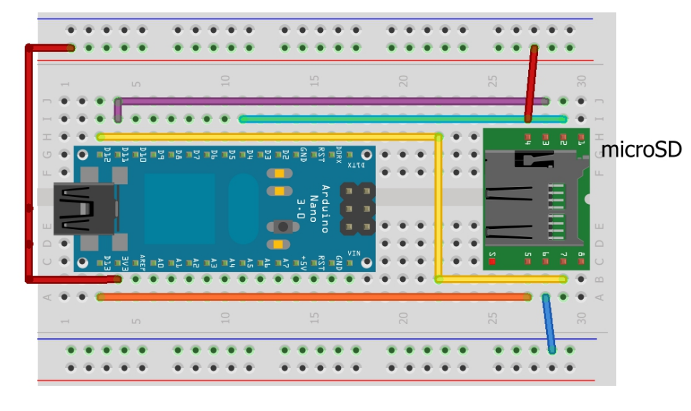ich can store sensor data until the available memory is filled. As shown in Figure 10 microcontrollers such as the Arduino Nano, can be integrated with simple plug-and-play flash memory cards [23]. Since it is possible that data will need to be manually uploaded from a personal computer, all system installations will need to be accessible by humans.

Figure 10: Micro SD Card interfacing with an Arduino Nano [24].

### Housing

Considering that the system will be exposed to environmental elements, the electronics in the system must be water resistant such that the bottom of the system is dry and precipitation will not enter the system to short circuit anything.  If the system is to be mounted on the top of the tanks, a basic concept would be simply a container with its lid with its sides overlapping the sides of the compartment.  A viable design has been commercially produced by Protocase, as shown in Figure 13. Protocase is a company that makes electronic containers of varying sizes, which can fit around this system.  Another option is to uniquely model a container to be 3D printed with the similar outline to fit the system snugly.

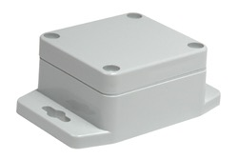

Figure 13: Sample of a Protocase box to contain and protect electronics [24].

The printed circuit board and other electronics that are in the final alternative would be stored within the box, but the wires and exterior parts may lead out from the box.  When there are parts extending from the box there should be sealant to fill the holes in the container.

The advantages of this design are that it can be mounted on any surface and affords easy access to the electronics within.  It also serves the purpose of protecting the electronics from weather and other environmental conditions.  One disadvantage would be the ease of theft, given the use of standard screws which easily be removed. Using tamper-proof screws, however, would prevent the electronics to be easily stolen.

If the team chooses to build the container in-house it may be necessary to waterproof it manually.  This can be simply accomplished by applying a sealant or liquid repellant coating.  More reliable coatings tend to run at a higher cost, which may exceed the target budget of $30 per unit [25][26].  If an entirely water-resistant system is preferred after testing, using O-rings would further seal gaps between the screws and container parts.

In regards to securing a solar panel, current literature has suggested the effectiveness or welding or gluing solar panels, or using one-way screws [27][28].  Further testing may demonstrate that one method is more effective than another.

## Preliminary design

In order to ultimately meet the cost constraint of this project, design alternatives for each subsystem will be tried in various combinations. The following sections describe the most promising first alternative the team will pursue, as broken down by subsystem.

### Power

The team will begin prototyping using the solar powered design alternative, aiming to build a fully self-sufficient system. Based on the power constraints of the rest of the system, the power supply may need to be adjusted. When a functional prototype has been built, financial and power costs will need to be reevaluated. If the cost of the solar power components can be minimized, while also fulfilling the power requirements of the system, solar power could be a sustainable, low-maintenance solution. Alternatively, systems that depend solely on batteries will be explored.

### Volume Sensing

Certain pressure sensors, ultrasonic sensors, and possibly a homemade resistance sensor are the only sensing methods within the $30 budget. Within this category, ultrasonic sensors are the least expensive. They also require less additional hardware compared to the pressure sensors. At least one type of ultrasonic sensor (HCS04) is available for less than $5, and it operates over the temperature and distance ranges expected. In addition, this sensor runs on 5V, well within the capabilities of all power alternatives under consideration. The HCS04 is also known to be Arduino-compatible, which will accelerate the sensing prototype process. The installation of an ultrasonic sensor requires only one opening at the top of the tank.  Although extensive testing of the ultrasonic sensor is required before it is adopted as a final design, the ultrasonic sensor is a clear frontrunner in fulfilling the functional constraints of this project.

To ensure that other in-budget sensing possibilities are fully explored, a differential pressure sensor will also be tested in a tank. The homemade resistance sensor might be explored later in an effort to reduce total cost, but it is a more invasive and likely less precise solution.

### System Control

The preliminary design of the system indicates that the performance and the number of I/O pins are not the main concerns. The system is required to transmit data only once every 24 hours, so the speed of the microcontroller does not play an important role in selecting a specific device. The cost of the system is also more important than the functionalities; as long as the system can achieve basic functionality, minimizing the cost is more critical than adding more features. As a result, the low-end microcontrollers: ATMega328 and ATTiny84 are more appropriate than their high-end alternatives.

ATMega328 surpasses ATTiny84 in terms of programmability since it is widely supported and is readily compatible with the Arduino platform. It can be directly programmed with Arduino IDE and with a development board Arduino UNO R3, which is commercially available. The through-hole counterpart of the chip will also allow the first prototyping phase to be done on breadboard without the development board. Additionally, ATMega328 has a more precise ADC converter than ATTiny84, so it can be used to directly accept sensitive analog inputs from a larger variety of analog sensors. This advantage will allow more alternatives for the sensing part of the system. Even though ATMega328 costs twice as much as ATTiny84, the price difference is only $1.25. Consequently, ATMega328 is chosen for the preliminary prototyping and testing. However, if it is necessary to reduce the price of the system further, the code written for ATMega328 can be translated to a code for ATTiny84 to reduce costs.

### Data Transmission

As stated previously, the primary transmission design will depend upon the availability of a cellular network at the installation sites for existing filtration systems. Preliminary research suggests that 2G networks do exist throughout most of these regions, so an approach utilizing a cellular network will be the primary design alternative. A microcontroller will be equipped to connect to the cellular network using a GSM module and SIM card. To allow for the extensibility of RainCatcher’s involvement to new areas of the globe, the system will not solely depend upon the availability of cellular networks but will also be designed to collect and store data on an SD card for implementation in locations where no network is available.

### Housing

The preliminary housing design will consist of a surface mounted container waterproofed using a sealant. The plastic used should be strong enough to withstand harsh environmental conditions.  In the prototyping phase the team will utilize a commercially available container, however, cost may later be reduced by designing a custom housing for the electronic components. The solar panels will be glued permanently to the container. To protect the system against theft, the fasteners used in the housing will be one-way screws which require a special tool to remove.

## testing

The team will need to concretely verify that the prototype meets the constraints and performs according to the project’s objectives. The first stage of testing will occur on campus, by either purchasing a small-scale water tank or by otherwise simulating onsite conditions. Once rigorous testing is completed, the next stage will involve field testing in the Navajo Nation in New Mexico to quantify reliability.  Finally, if the Navajo Nation testing proves promising, further work will be done to polish the design and take it to Uganda or Kenya for the final phase of testing.

To test the power system, the solar panels and power system will be left outside during sunlight hours. The amount of power collected by the panel will be tracked by the amount of charge in the batteries. A critical variable in the function of the power subsystem is the incident angle of sun rays. The testing procedure will determine the ideal angle of incidence for maximizing energy storage. A third variable to consider is the amount that cloud coverage affects the collection of power. Once the team has confirmed that sufficient power can be supplied to the system, the team will test the entire system using the collected solar power. The control of the power of the system will also involve extensive testing to ensure batteries are being charged safely over long periods of time.

The sensors will be tested with the microcontroller to ensure a reliable connection and accurate data measurement.  Subsequently, it will be tested under environmental conditions similar to that of the existing tanks, specifically in cases where moisture and flowing water will enter the tank.

The majority of testing for the microcontroller is focused on the coding and wiring of the circuit.  The system will be continually tested in development until the microcontroller can send data reliably. Initial testing will involve using Arduino for ease of programming, but eventually, the circuit will be built with the stand-alone chip.

To test data transmission, the team will set up the prototype and send small packets of data through the cellular network. If this test is successful, the prototype may be tested under disrupted network conditions. A test will consist of disconnecting the system from the cellular network and checking if the data collected is stored and later transmitted upon reconnection. This would test the functionality of the system when the cellular network is unreliable or variable. If the cellular network solution fails, the team will consider the packet radio implementation as a secondary approach.

The housing will be tested to ensure security and water-tightness.  To test for water-tightness, the housing will be set on top of an elevated flat surface positioned over a bucket.  Water will be poured over the housing container and runoff will be retained in the bucket.  The major test will be to check that the housing does not trap standing water. The secondary test will be the amount of moisture found inside the system. If an initial test is unsatisfactory, then further waterproofing methods will be used and tested.

Initially, testing will occur independently for each subsystem, but as components prove promising, the full system will require additional testing. The team will ensure that all subsystems cooperate well together and use the expected power consumption. The complete prototype will be tested under a variety of potentially detrimental environmental conditions. To confirm self-sufficiency, the system will be run and tested over multiple days. The team will conduct integrated testing under low sunlight conditions, testing the effect of precipitation on the system in the event of tank overflow. Finally, the system will be tested under a variety of weather conditions such as extreme wind, heat, and cold.

# Project Management

The RainCatcher Clinic Team has developed a work breakdown structure identifying the tasks to be performed, a Gantt chart laying out the critical path through the project, and an initial partitioning of the labor among team members.

## Work Breakdown Structure

The work breakdown structure in Figure 14 shows how the project has been hierarchically subdivided into more specific and manageable tasks.

**Activity Time (hours)**

Background research *(already complete) 10%*

Lab testing 45

Field testing 5

Existing solutions 2

RainCatcher 4

Team Meetings 15%

Teleconferences 30 × 5 × 1 = 150

Administrative Internal Team Meetings 30 × 5 × .5 = 75

Team Leader Meetings 7

Presentation and Preparation 10%

Orientation Day 3 × 5 = 15

Fall Review #1 2 × 5 = 10

Fall Review #2 3 × 5 = 15

Fall Review #3 3 × 5 = 15

Fall Site Visit 6 × 5 = 30

Spring Presentation 6 × 5 = 30

Projects Day Presentation 6 × 5 = 30

Design 20%

Conceptual Design 50%

Research

Power Supply 6

Sensors 6

System Control 6

Data Transmission 6

Housing 2

Comparison of Alternatives 3 × 5 = 15

Detailed Design *(significant uncertainty in these initial estimates) 50%*

Component selection 10

Prototyping

Integrating components 20

Iterative prototyping 40

Testing *(significant uncertainty in these initial estimates pending results) 30%*

Test Plan

Initial component testing

Power 4

Sensors 2

System Control 2

Transmission 4

Housing 2

Prototype testing

Spring Site Visit (Navajo Nation) 48 × 5 = 240

Components 30

In house 50

Field 20

Reports 15%

Team Charter 5

Work Plan

Background 20

Design Alternatives 20

Testing 5

Project Management 20

Other sections 10

Writing Center Review 2

Midyear Report 80

Final Report 80

Total Time 1326

Figure 14 : Work Breakdown Structure

## Schedule

The Gantt chart in Figure 15 shows that the critical path for the fall involves conceptual design, selection of a preferred alternative, detailed design for that alternative, and sending the design for manufacturing. The team anticipates testing, redesign, and further testing in the spring; the details will be flushed out in the Midyear report based on the fall progress.

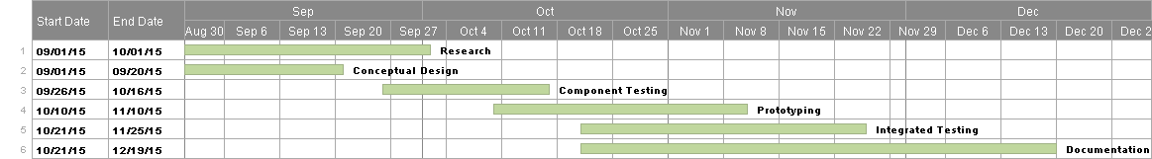

Figure 15 Gantt chart

## Division of labor

The team anticipates the following division of the major tasks in the project:

**Activity Owner**

Conceptual Design

Power Supply Nithya, Michael, Cherlyn

Sensors Nithya, Jozi

System Control Michael

Data Transmission Jozi, Heather, Michael

Housing Cherlyn

Detailed Design

Component selection All

Integrating components All

Iterative prototype All

Test Plan Cherlyn

Testing All

Presentation and Preparation All

Reports All

# References

1. “How do batteries work?” [Online]. Available: http://www.qrg.northwestern.edu/projects/vss/docs/power/2-how-do-batteries-work.html. [Accessed: September 24, 2015].
2. “How does a battery work?” May 2012. [Online]. Available: http://engineering.mit.edu/ask/how-does-battery-work. [Accessed: September 24, 2015].
3. “Cell Chemistries” May 2012. [Online]. Available: http://www.mpoweruk.com/chemistries.htm. [Accessed: September 24, 2015].
4. “Solar Battery Charging” [Online]. Available: http://www.reuk.co.uk/Solar-Battery-Charging.htm. [Accessed: September 24, 2015].
5. “IOM_291.pdf,”[Online]. Available:  http://www.dwyer-inst.com/PDF_files/IOM_291.pdf. [Accessed: September 20, 2015].
6. “Custom Fuel Tank Probes, Float Kits, and Tank Level Gauge by Veeder-Root,” [Online]. Available: http://www.veeder.com/us/probe-float-kit-tank-level-gauge. [Accessed: September 20, 2015].
7. Harris, David Money., and Sarah L. Harris. *Digital Design and Computer Architecture*. Waltham, MA: Morgan Kaufmann, 2013. Print.
8. “Definition of Microcontroller,” [Online]. Available: http://www.pcmag.com/encyclopedia/term/46924/microcontroller. [Accessed: September 24, 2015].
9. “How to Send AX.25 UI Frames with Using Inexpensive PIC Microcontrollers”. TAPR/ARRL Digital Communications Conference Papers. 1998. [Online]. Available: http://tnc-x.com/dcc.doc. [Accessed: September 23, 2015].
10. “How to Receive AX.25 UI Frames with Using Inexpensive PIC Microcontrollers”. TAPR/ARRL Digital Communications Conference Papers. 2000. [Online]. Available: http://tnc-x.com/dcc2.doc [Accessed: September 23, 2015].
11. “SMS GSM Modem Platform,” [Online]. Available: http://www.sandcti.com/sms_mms/sms_gsm_SAND.php. [Accessed: September 24, 2015].
12. “Wireless infrastructure for remote environmental monitoring: Deployment and evaluation” Mobile and Wireless Networking (MoWNeT), 2013 International Conference on Selected Topics in Networking. 2013. [Online]. Available: http://ieeexplore.ieee.org/stamp/stamp.jsp?tp=&arnumber=6613799. [Accessed: September 12, 2015].
13. “Arduinothing - Water Sensor,” [Online]. Available: http://arduinothing.wikispaces.com/Water+Sensor. [Accessed: September 20, 2015].
14. “8 eTape Liquid Level Sensor + Extras ID: 463 - $39.95 : Adafruit Industries, Unique & Fun DIY Electronics and Kits,” [Online].  Available: http://www.adafruit.com/products/463?gclid=CNX3vI3XkcgCFQ5rfgodLOoElA. [Accessed: September 20, 2015].
15. “MPX5050DP Freescale Semiconductor | MPX5050DP-ND | DigiKey,” [Online]. Available: http://www.digikey.com/product-detail/en/MPX5050DP/MPX5050DP-ND/464057. [Accessed: September 20, 2015].
16. “MPXV7002 Integrated Silicon Pressure Sensor On-Chip Signal Conditioned, Temperature Compensated and Calibrated - Data Sheet - 4mpxv7007.pdf,” [Online]. Available: http://download.siliconexpert.com/pdfs/2015/1/28/7/24/33/412/fsl_/manual/4mpxv7007.pdf. [Accessed: September 21, 2015].
17. “HC-SR04 User’s_Manual,” [Online]. *Google Docs*. Available:  https://docs.google.com/document/d/1Y-yZnNhMYy7rwhAgyL_pfa39RsB-x2qR4vP8saG73rE/edit?usp=embed_facebook. [Accessed: September 21, 2015].
18. “Arduino/Genuino UNO,” [Online]. Available: https://www.arduino.cc/en/Main/arduinoBoardUno. [Accessed: September 24, 2015].
19. “Arduino Comparison Chart,” May 2015, [Online]. Available: https://learn.adafruit.com/adafruit-arduino-selection-guide/arduino-comparison-chart. [Accessed: September 24, 2015].
20. “Tiny AVR Programmer Hookup Guide,” [Online]. Available: https://learn.sparkfun.com/tutorials/tiny-avr-programmer-hookup-guide. [Accessed: September 24, 2015].
21. “AX.25 Link-Layer Protocol Specification,” [Online]. Available: https://www.tapr.org/pub_ax25.html. [Accessed: September 24, 2015].
22. “Atmel’s Self Programming Microcontrollers,” [Online]. Available: http://www.atmel.com/Images/doc2464.pdf. [Accessed: September 24, 2015].
23. “Mass Storage Device- USB Flash Drive,” [Online]. Available: http://www.atmel.com/Images/pc_peripherial_flash_drive_diagram_lg.jpg. [Accessed: September 24, 2015].
24. “WP-20F Polycarbonate Electronic Enclosure with NEMA Rating,” [Online]. Available: http://www.polycase.com/wp-20f#. [Accessed: September 24, 2015].
25. Roach, Paul, Neil J. Shirtcliffe and Michael I. Newton. “Progress in superhydrophobic surface development,” [Online]. Available: http://citeseerx.ist.psu.edu/viewdoc/download?doi=10.1.1.493.5837&rep=rep1&type=pdf. [Accessed: September 24, 2015].
26. “Hydrobead: Consumer Products,” [Online]. Available: http://www.hydrobead.com/#!consumer/component_41229. [Accessed: September 24, 2015].
27. “Solar Panel Theft: How Do You Prevent It?” [Online]. Available: http://www.treehugger.com/solar-technology/solar-panel-theft-how-do-you-prevent-it.html. [Accessed: September 24, 2015].
28. “Solar Panel Security- Anti-Theft Devices” [Online]. Available: http://www.energymatters.com.au/panels-modules/solar-panel-security/. [Accessed: September 24, 2015].
29. team member profiles

Cherlyn Chan is a junior engineering major at Harvey Mudd College.  She is interested in pursuing mechanical engineering with some emphasis on sustainability and environmental applications.  In her past internships and education, she has gained experience in designing mechanical systems in CAD and implementing sensors in electrical systems.  She has a passion to use her knowledge in science and technology to serve those who are lacking basic necessities, such as access to clean water.

Pichaya Michael Lertvilai is a senior engineering major at Harvey Mudd College. His interest lies in the field of environmental engineering as he believes that engineering approach is an essential part of the solution to environmental problems the world is facing. RainCatcher Global Clinic is an opportunity for him to use his engineering skills to help solve one of the important environmental problems: clean water availability. Throughout his education at Harvey Mudd College, Michael has worked with various types of sensors, designed printed circuit boards and built many microprocessor-based systems. His engineering background in system design and electrical engineering will be able to contribute to the success of the project.

Jožefa (Joži) McKiernan is a senior Mathematical and Computational Biology major. While her primary interest is biology, she really loves interdisciplinary work that applies biological principles, and is considering a career in bioengineering or synthetic biology. Joži has significant experience scripting and working with mathematical models. She is also familiar with engineering and design thanks to college classes and involvement in FIRST robotics. Joži works in the Writing Center on campus. This semester, she is continuing to do biophysics research on morning glory petal motion with Professor Gerbode.

Nithya Menon is a senior engineer at Harvey Mudd College. Her background is split between computer science and engineering, where her engineering focus is on electrical and mechanical systems, especially the combination of the fields. The most important part of her interest in technology is the element of global and social impact that drives her forward. She would love to use her technical knowledge to boost people’s potential for sustainable growth around the world. She has done work with global education and the sustainable development goals, and being able to affect change in these areas is something she is passionate about.

Heather Seaman is a Senior Joint Computer Science and Mathematics Major at Harvey Mudd College. Her interests include application development, databases, networking, UX/UI design, as well as business and project management. She has substantial web application development experience, primarily with Node.js, but has also worked in Java, C++, Python, and HTML/CSS. She has also completed significant data analysis problems throughout her coursework at Harvey Mudd College. Heather’s interest in the RainCatcher project stem from a desire to improve the lives of people around the world by enhancing their quality of life and efficiency in daily tasks.